EEEN30160 – Biomedical Signal Processing


Assignment 1

  - Oisín Hogan
  - 19355123

Contents
Problem 1: 3
Code: 3
Output 4
Discussion 4
Problem 2: 5
Code: 5
Outputs: 5
Discussion: 5
Problem 3: 6
Code: 6
Output: 6
Discussion 6
Problem 4: 7
Code: 7
Output: 7
Discussion: 8
Problem 5 9
Code: 9
Output: 10
Discussion: 10
A 10
B 10
C 10
D 10
E 10
F 10
G 10
H 10

Problem 1:

Code:
function plotsinusoid2(f,a,startT,endT,step)
%plot a complex sinusoid of frequency, 'f' and amplitude, 'a', with 'startT'
%and 'endT' giving the bouns of the time and 'step' giving the step size
t = (startT:step:endT); % create array of timesf from start to end in the specified step size
compx = a*exp(2*pi()*f*t*i); % create a complex number using the specified inputs
Rex = real(compx);%get the real component of compx
Imx = imag(compx);%get the imaginary component of compx
Ax = (t*0)+a;% create an amplitude array that is the same size as t
tiledlayout(2,1)% create a 2 graph tiled layout to plot the angle and x
nexttile %go to the first tile
plot(t,Rex, 'r--') % plot the real part of x in red dashed line
hold on % keep the real part of x
plot(t,Imx, 'b-.'); % plot the imaginart part of x in a blue dot and dashed line
plot(t,Ax,'g-') % plot the amplitude of x
xlabel('time') % label x axis as time
ylabel('amplitude')% label y axis as amplitude
ylim ([-a-1 a+1]) % add 1 to the y bounds, as to increase the amount of graph shown
legend('Re(x)', 'Im(x)', 'Amp(x)')%add a legend
title('PlotSinusoid2 - Amplitude')%add a title
nexttile % next tile
plot(t,(360*f*t))% Plot the angle vs time
xlabel('time')%label x
ylabel('Angle')%label y
title('PlotSinusoid2 - Angle')% title

return
end

Output
Figure 1

Discussion
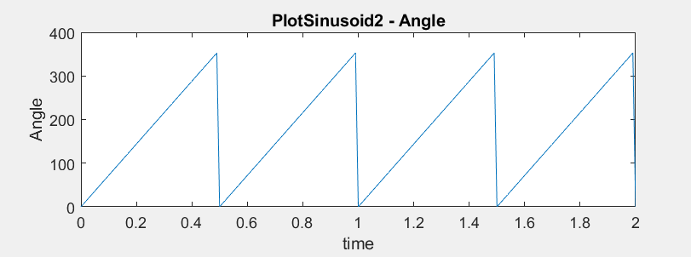
The real and imaginary parts of the complex number are separated by a quarter step. The angle graph could be changed to reset to 360 each iteration using the modulo function, mod(a,x) , but this was not deemed necessary, when this was done, the graph looked like this:
Figure 2

Problem 2:

Code:
a = load('C:\Users\Oisin\Documents\MATLAB\Signal processing\EvokedPotential.mat'); % load file as 'a'
b = a.EvokedPotential;%let 'b' equal the evoked potential part of 'a'
l = size(b); % let 'l' equal the size of 'b'
t = [-100:650]; % let t range from -100 to 650 ms
plot(t, b)% plot 'b' against 't', each 1 on the x axis is equal to 1 ms
xlabel('time - ms')% label the x axis as time in ms

Outputs:
Figure 3

Discussion:
The file was read into MATLAB and then plotted from the range of -100ms to 650ms, when this was done, the peak was found to be at 120ms, meaning that the subject was neurologically healthy.

Problem 3:

Code:
function ans = rmsfunct(n) % function to calculate the rms of a siganl
x = n.^2*sqrt(2);% let x be the square of each element in the array n, times root 2
N = size(n);% let N be the size of x
ans =sqrt(1/N(2)*sum(x.^2)); % ans equal ro the rms, done with the given function in the problem
end

n = [-728:0.5:1275]; % let n be an array from -728 to 1275 in steps of 0.5
rmsfunct(n)% calculate the rms of n

Output:
ans =

8.4514e+05

Discussion
The root mean square of this signal was 85140, when compared to the built in MATLAB function rms(), this number was confirmed

Problem 4:

Code:
struct = load('C:\Users\Oisin\Documents\MATLAB\Signal processing\EMG.mat');% load in EMG signal
vect = struct.EMG; %let 'vect' be the EMG signal
avect = abs(vect); %get absolute value of vect
plot(avect) %plot avect

lb = 4664;% lower bound observed from graph
ub = 11759;% upper bound observed from graph
avs =avect(lb:ub); %set the signal component of 'avect'

avnb = avect(1:lb); % set the lower bound of the noise component of 'avect'
avna= avect(ub:16001); % set the upper bound of the noise component of 'avect'
avn = [avnb; avna];% add them both together to get the total noise of 'avect'
ravn = rms(avn);% get rms of noise
ravs = rms(avs);% get rms of signal

SNR = 20*log(ravs/ravn) % use the rms values to get the SNR

Output:
Figure 4

SNR =

51.0796

Discussion:
The signal frequency was Hz, and the noise frequency was Hz. The signal noise ratio was 51.0796.

Problem 5

Code:
struct = load('C:\Users\Oisin\Documents\MATLAB\Signal processing\vep.mat'); % read in the vep file
sigs = struct.vep;% get the signals from struct
sizes = size(sigs);% get the dimensions of sigs
Diff_Min_Max = max(sigs)- min(sigs); % find the difference between the min and max values of signal
avgdiff = mean(Diff_Min_Max);% find the mean difference of the signals
filteredvep = mean((sigs.'));% filtered vep is the mean of all the signals, .' transposes the matrix to ensure its the right dimensions
plot(sigs, '--')% plot all the signals in red dashed lines
hold on% hold all the signals
plot(filteredvep, 'K')%plot the filtered vep in black
ylabel('mV')% label the y axis as mV
maxv = max(filteredvep); % find the max of the filtered vep
minv = min(filteredvep); %find the min of the filtered vep
tmax = find(filteredvep == maxv);% find the time that the max occurs
tmin = find(filteredvep ==minv);% find the time that the min occurs
tdiff = abs(tmax - tmin);% find the difference in times
diffavg = maxv- minv;% find the average difference in the largest and smallest value
var20 = (std(sigs(1:20, :))).^2; % find the varience of the first 20 time steps of the signas
avgvar20 = mean(var20); % find the mean of these variences
varavg20 = (std(filteredvep(1:20)))^2; % vind the varience of the first 20 time steps of the filtered signal

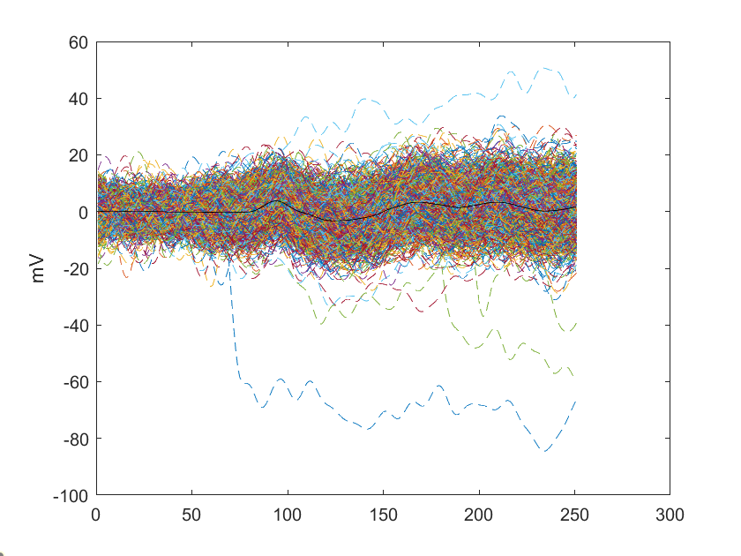
Output:
Figure 5

Discussion:

A
Figure 5 has all the signals plotted together, all shown in different colour dotted lines

B
The Diff_Min_Max was a 1 x 1263 array, where it was found by subtracting the max and min arrays from each other.

C
The average value for Diff_Min_Max was found to be 24.230395622150300

D
The filtered vep, or the average epoch is shown in Figure 5 in black.

E
The max and min points of the vep occurred at 94 samples and 124 samples, with a time between occurrences of 30 samples.

F
Because the average difference across all the trials looks at the extreme values, and the filtered signal has softened the large peaks of them, leading to a much smaller difference between the extremes.

G
The variance of the different epochs for the first 20 frames was a 1263 x 1 array, with the average value of 10.439121218095861

H
The variance of the first 20 samples of the filtered vep was 0.007396304600416, this was a lot lower than the average variance, as the extreme outliers that would have a large effect on the data were removed in the vep, leading to a much lower varience

